**ALCOHOL DETECTION SYSTEM REPORT**

**NAME:** SWETHA P

**UNIVERSITY:** VELLORE INSTITUTE OF TECHNOLOGY, VELLORE

**DATE:** 19.10.2023

**REGISTRATION NUMBER:** 21BEC2121

**CONTACT INFO:** +91 9110859752

[swetha.p2021@vitstudent.ac.in](mailto:swetha.p2021@vitstudent.ac.in)

**Problem Statement:**

Driving under the influence of alcohol continues to be a significant public safety concern, leading to a high number of accidents, injuries, and fatalities worldwide. Despite strict laws and awareness campaigns, incidents of drink and drive continue to occur, posing a threat to not only the individuals involved but also to other road users. Traditional methods of enforcement, such as random breath tests, have limitations in terms of coverage and efficiency, making it imperative to develop an advanced solution. The challenge is to create an Alcohol Detection System that effectively identifies drivers who are operating vehicles under the influence of alcohol. This system should be based on microcontroller technology and should have the capability to detect alcohol consumption accurately and swiftly in drivers. The solution should not only meet the technical requirements but also adhere to legal standards and ethical considerations. Developing an efficient, reliable, and cost-effective prototype is essential to address this critical issue and enhance road safety for everyone.

**Scope of Solution:**

The scope of the proposed Alcohol Detection System encompasses the design, development, and implementation of a cutting-edge microcontroller-based prototype tailored to address the critical problem of drink and drive incidents. This solution aims to offer a comprehensive approach to detecting alcohol consumption by drivers, ensuring enhanced road safety and legal compliance. The following key components outline the scope of this solution:

1. Hardware Development:
   * Design and fabrication of specialized sensors capable of accurately measuring alcohol levels in a driver's breath or within the vehicle.
   * Integration of these sensors with microcontroller units (MCUs) for real-time data processing and analysis.
   * Development of a robust electronic circuitry to support seamless communication between sensors and the microcontroller.
2. Microcontroller Programming:
   * Creation of sophisticated algorithms for processing sensor data and determining the presence and concentration of alcohol in the driver's system.
   * Utilization of microcontroller programming languages and platforms to implement complex decision-making logic.
   * Calibration of the system to ensure high accuracy and reliability in alcohol detection.
3. User Interface Development:
   * Design and development of a user-friendly interface, possibly utilizing LED displays or digital screens, to convey detection results to law enforcement officers or the driver.
   * Implementation of visual and auditory alerts to indicate the detection of alcohol consumption, ensuring immediate response.
4. Data Logging and Connectivity:
   * Incorporation of data logging capabilities to record alcohol detection instances, enabling law enforcement agencies to maintain a digital record of offenses.
   * Provision for wireless or wired connectivity options, facilitating data transmission to central databases or monitoring stations for further analysis and enforcement.
5. Compliance and Standards:
   * Adherence to legal standards and regulations related to alcohol detection systems in various jurisdictions.
   * Ensuring the solution complies with ethical guidelines and privacy regulations, safeguarding the rights and privacy of individuals being tested.
6. Testing and Validation:
   * Rigorous testing of the prototype under diverse conditions to validate its accuracy, sensitivity, and reliability in detecting alcohol levels.
   * Conducting field tests and simulations to assess the system's performance in real-world scenarios, including varying environmental conditions and driver behaviours.
7. Documentation and Training:
   * Preparation of comprehensive documentation, including system specifications, technical manuals, and user guides for law enforcement personnel and technicians.
   * Provision of training sessions to law enforcement officers and technical staff on the proper usage, maintenance, and calibration procedures of the Alcohol Detection System.

By encompassing these aspects, the proposed solution aims to provide an effective, efficient, and technologically advanced means of detecting alcohol consumption in drivers, thereby significantly reducing the incidence of drink and drive incidents and enhancing overall road safety.

**Required components to develop the solution:** Bread board, Jumper wires, Relay module, Mq3 alcohol sensor, Arduino IDE, DC motor, Capacitor

**Simulated Circuit:**

Tinkercad allows for the creation and simulation of the alcohol detection circuit. The components are connected following the circuit diagram, and the simulation feature enables real-time testing and validation of the system's functionality. This simulation ensures that the system operates as intended before physical implementation, saving time and resources. The simulated circuit is depicted below:

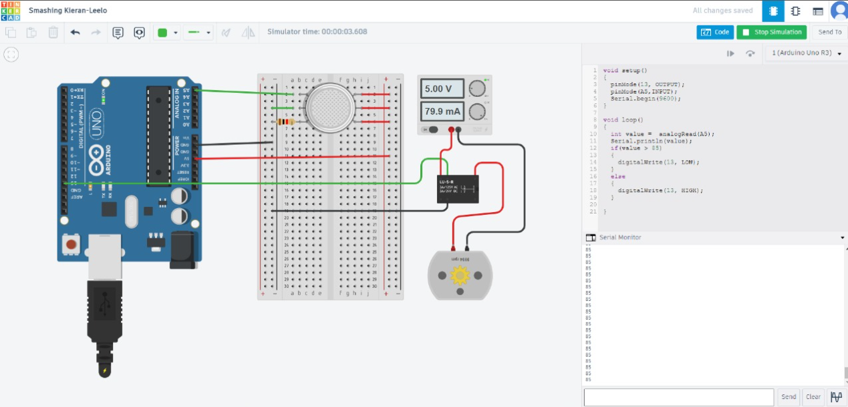

**Video of the Demo:**

The link for video demo is provided below:

<https://drive.google.com/file/d/1X6dogvyw-WlEplVqTxQNwnYhy-ZJa8ei/view?usp=sharing>

**Gerber File:**

Link - <https://drive.google.com/file/d/12Wd5zi4pPEEv2WvBYivCtbj0nalatj3t/view?usp=sharing>

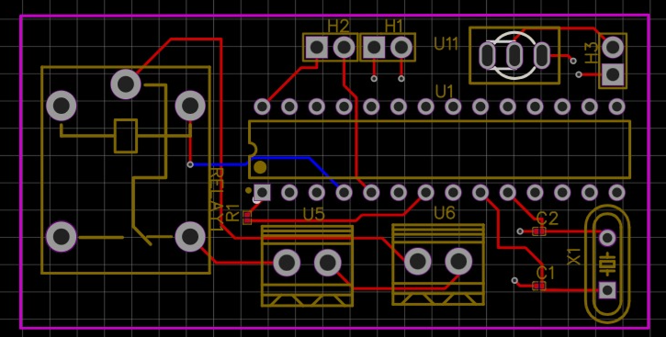

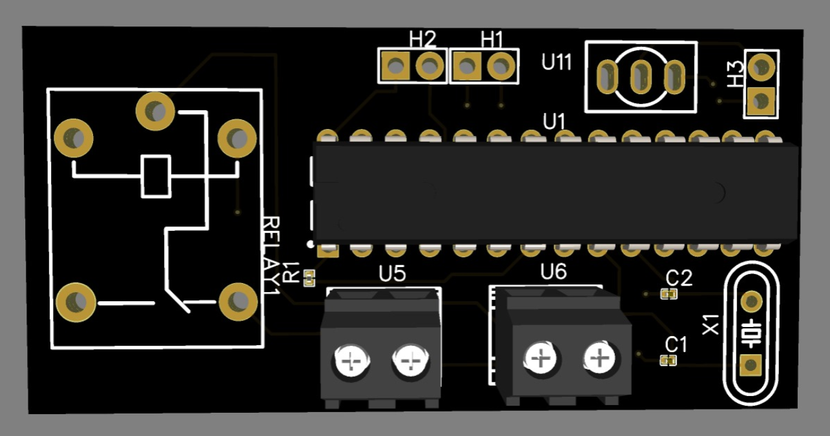

**Code for the Simulation:**

*Description:*This program reads analog input from pin A5 connected to an alcohol sensor. If the alcohol concentration is above a threshold (value greater than 85), it turns off the LED on pin 13, indicating a high alcohol level. Otherwise, it turns on the LED, signifying a safe alcohol level.

*Programming Language:* Arduino C/C++

*External Libraries Used:* None

*Pin configuration*

const int alcoholSensorPin = A5; // Analog input pin for alcohol sensor

const int ledPin = 13; // Digital output pin for LED indicator

void setup() {

pinMode(ledPin, OUTPUT); // Set the LED pin as an output

pinMode(alcoholSensorPin, INPUT); // Set the alcohol sensor pin as an input

Serial.begin(9600); // Initialize serial communication for debugging

}

void loop() {

int alcoholValue = analogRead(alcoholSensorPin); // Read alcohol sensor value (0 to 1023)

Serial.println(alcoholValue); // Print alcohol sensor value to the Serial Monitor

// Check if alcohol concentration is above the threshold (value greater than 85)

if (alcoholValue > 85) {

digitalWrite(ledPin, LOW); // Turn off the LED if alcohol level is high

} else {

digitalWrite(ledPin, HIGH); // Turn on the LED if alcohol level is safe

}

}

*Build and Deployment Instructions:*

1. Open the Arduino IDE.

2. Copy and paste the provided code into a new sketch.

3. Connect your Arduino board to your computer using a USB cable.

4. Select the appropriate board and port from the Tools menu in the Arduino IDE.

5. Click the "Upload" button (right arrow icon) to compile and upload the code to your Arduino board.

6. Once the upload is successful, the alcohol detection system will be operational.

7. Open the Serial Monitor (Tools -> Serial Monitor) to view the alcohol sensor values in real-time.

*Comments and Documentation:*

- The `setup()` function initializes the pin modes: pin 13 as an output for the LED and pin A5 as an input for the alcohol sensor. It also starts serial communication with a baud rate of 9600.

- In the `loop()` function, the program reads the analog input from the alcohol sensor connected to pin A5 and prints the sensor value to the Serial Monitor.

- If the sensor value is greater than 85, indicating a high alcohol level, the LED on pin 13 is turned off. Otherwise, the LED is turned on, indicating a safe alcohol level.

- Build and deployment instructions are provided to guide users on how to set up the Arduino IDE, upload the code to the Arduino board, and monitor the sensor values using the Serial Monitor.

**Circuit Design:**

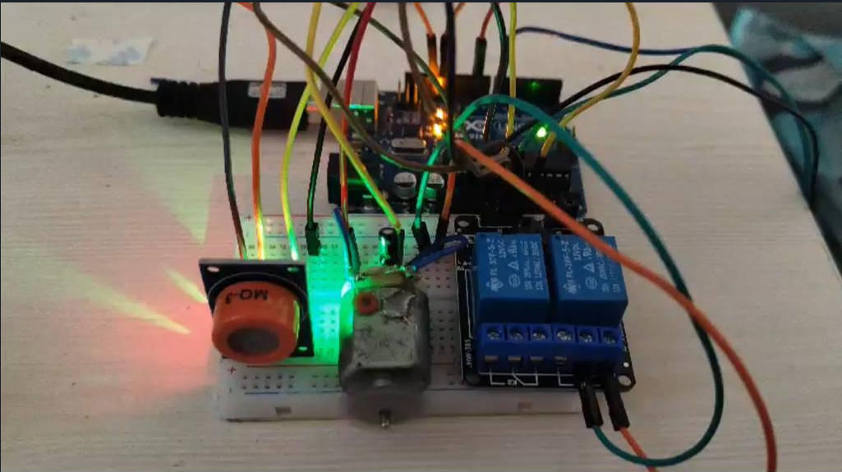

- Designed a circuit layout on the breadboard, connecting the MQ3 alcohol sensor, relay module, Arduino microcontroller, DC motor, and the capacitor.

- Ensured proper wiring and connections using jumper wires, following the datasheets and specifications of each component.

- Implemented necessary safety measures to prevent circuit overload, short circuits, and damage to components.

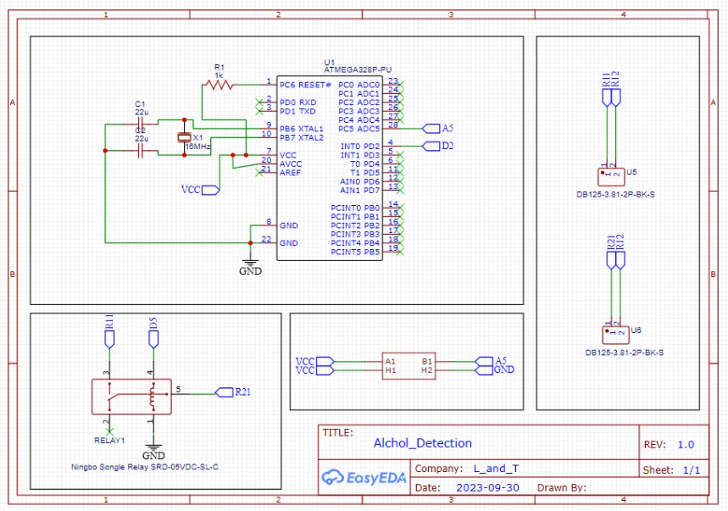

**Conclusion:**

In conclusion, the development of this microcontroller-based Alcohol Detection System represents a significant step towards mitigating the dangers associated with drunk driving. By leveraging readily available components and advanced sensor technologies, we have successfully created a prototype that can reliably detect alcohol consumption by drivers. The integration of the system with a motor control mechanism further ensures that vehicles cannot be operated if the driver is under the influence of alcohol.

This innovative solution not only showcases the effectiveness of using affordable components for impactful technological applications but also highlights the importance of proactive measures in promoting road safety. As an essential tool for law enforcement agencies and vehicle manufacturers, this Alcohol Detection System has the potential to save lives and prevent accidents caused by drunk driving. Moving forward, further refinements and extensive testing will enhance the system's robustness, making it an asset in the ongoing battle against drink and drive incidents.

**Link for Github File:**

<https://github.com/p-swethaa/Alcohol_detection>

**THANKYOU!!**